[**Casa per ferie Villa Maria**](http://www.villamaria.pcn.net/)

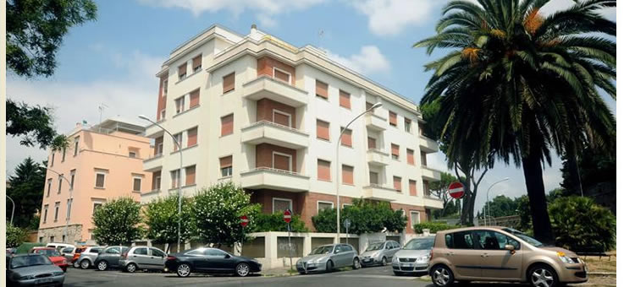

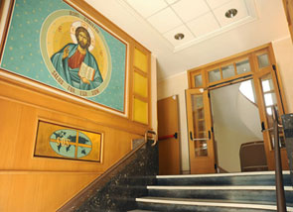 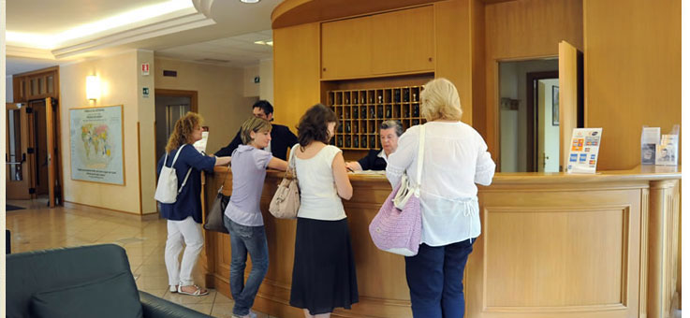

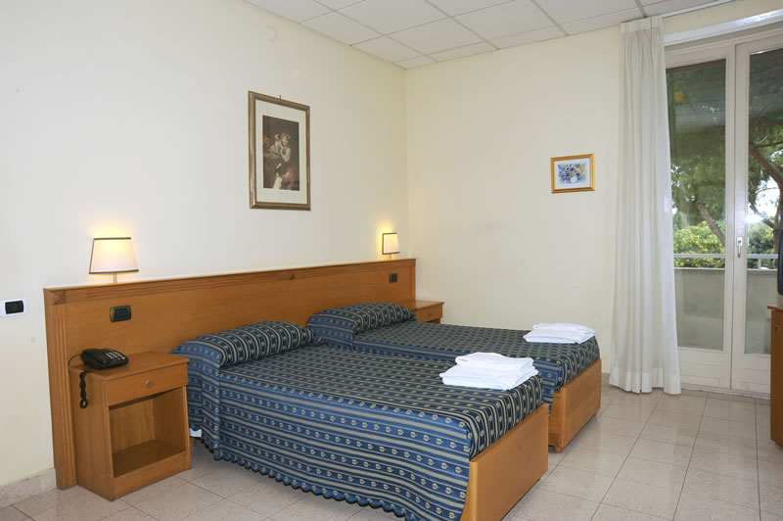 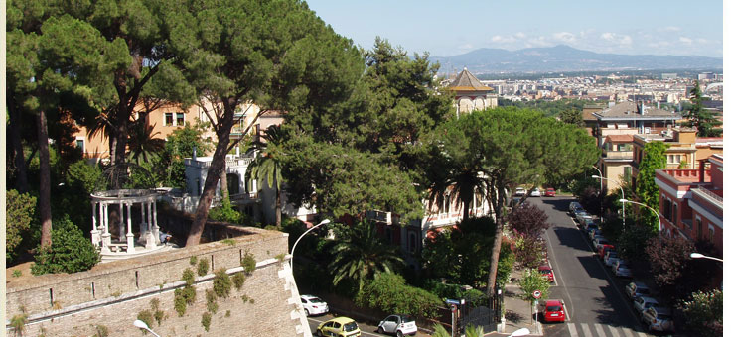

[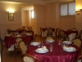](http://www.villamaria.pcn.net/wp-content/gallery/gallery/img_0016.jpg)[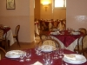](http://www.villamaria.pcn.net/wp-content/gallery/gallery/img_0019.jpg)